APOL MEDRANO
Heritage University 08 -28 -23
Mathematics and Computer Science Dept. Due: 09 -03 -23

C++
Homework 1
(if, else, while loop)

1.The Babylonian algorithm to compute the square root of a number n is as
follows:
- Make a guess at the answer (you can pick n/2 as your initial guess)
- Compute r=n/guess
- Set guess = (guess + r)/2
- Go back to step 2 for as many iterations as necessary. The more that step 2 and 3 are repteated, the closer guess will become to the squre root of n.
Write a program that inputs a double fror n and iterates through the Babylonian algorithm 100 times. For a more challenging version, iterate until guess is within 1% of the previous guess, and outputs the answer as double. Ch2, #2, practice, p.104

100 times version:

#include <iostream>
using namespace std;
int main ()
{
double n, r, guess, count = 1;

cout.setf(ios::fixed);
cout.setf(ios::showpoint);
cout.precision(10);

cout << "Insert number that you would like to find the square root of: ";
cin >> n;

cout << "Now make an intially guess of what they square root may be: ";
cin >> guess;

while (count++ < 100)
{
(r = n/guess);
(guess = (guess + r)/2);
}

cout << "The square root of " << n << endl;
cout << "is " << guess << ".\n";
return 0;
}

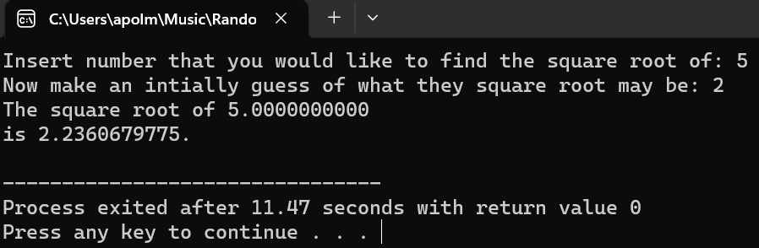

1% between previous guess version:

#include <iostream>
using namespace std;
int main ()
{
double n, r, guess, count = 1;

cout.setf(ios::fixed);
cout.setf(ios::showpoint);
cout.precision(10);

cout << "Insert number that you would like to find the square root of: ";
cin >> n;

cout << "Now make an intially guess of what they square root may be: ";
cin >> guess;

while ((guess*guess<= 0.99*n)||(guess*guess>=1.01*n))
{
(r = n/guess);
(guess = (guess + r)/2);
}

cout << "The square root of " << n << endl;
cout << "is " << guess << ".\n";
return 0;
}

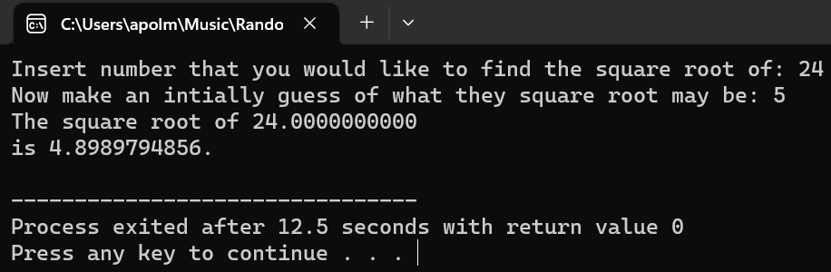

2. Workers at a particular company have won a 7.6% pay increase retroactive
for six months. Write a program that takes an employee’s previous annual
salary as input, and outputs the amount of retroactive pay due the employee,
the new annual salary, and the new monthly salary. Use a variable declaration
with the modifier const to express the pay increase. Your program
should allow the calculation to be repeated as often as the user wishes.
Ch2, #2, proj. p106
#include <iostream>
using namespace std;
int main ()
{
double as, rp, new_as, new_ms;
const double inc = 0.076;
char ans;

cout.setf(ios::fixed);
cout.setf(ios::showpoint);
cout.precision(2);

do
{
cout << "Hello!" << endl
<< "Insert your annual pay to recieve your retroactive pay for the last 6 months" << endl
<< "(Please do not use any commas, and don't forget to hit the return key after you enter it) \n";
cin >> as;
cout << "Your annual pay is of right now is " << as << " dollars." << endl;

(rp = (as/2) * inc);
cout << "Your retroactive pay is " << rp << " dollars." << endl;

(new_as = (rp + as));
cout << "Your new annual salary is " << new_as << " dollars." << endl;

(new_ms = (new_as/12));
cout << "Your new monthly salary is " << new_ms << " dollars." << endl;

cout << endl;
cout << "Would you like to do another calculation of a annual salary with 6 months of retroactive pay?\n";
cout << "Press y for yes" << endl
<< "Press n for no" << endl;
cin >> ans;
cout << endl;
} while (ans == 'y' || ans == 'Y');

cout << "Before you go, I would like to congratulate you on working hard to earn the retroactive pay!" << endl
<< "You deserve it and I hope you have an amazing rest of your day!\n";
return 0;
}

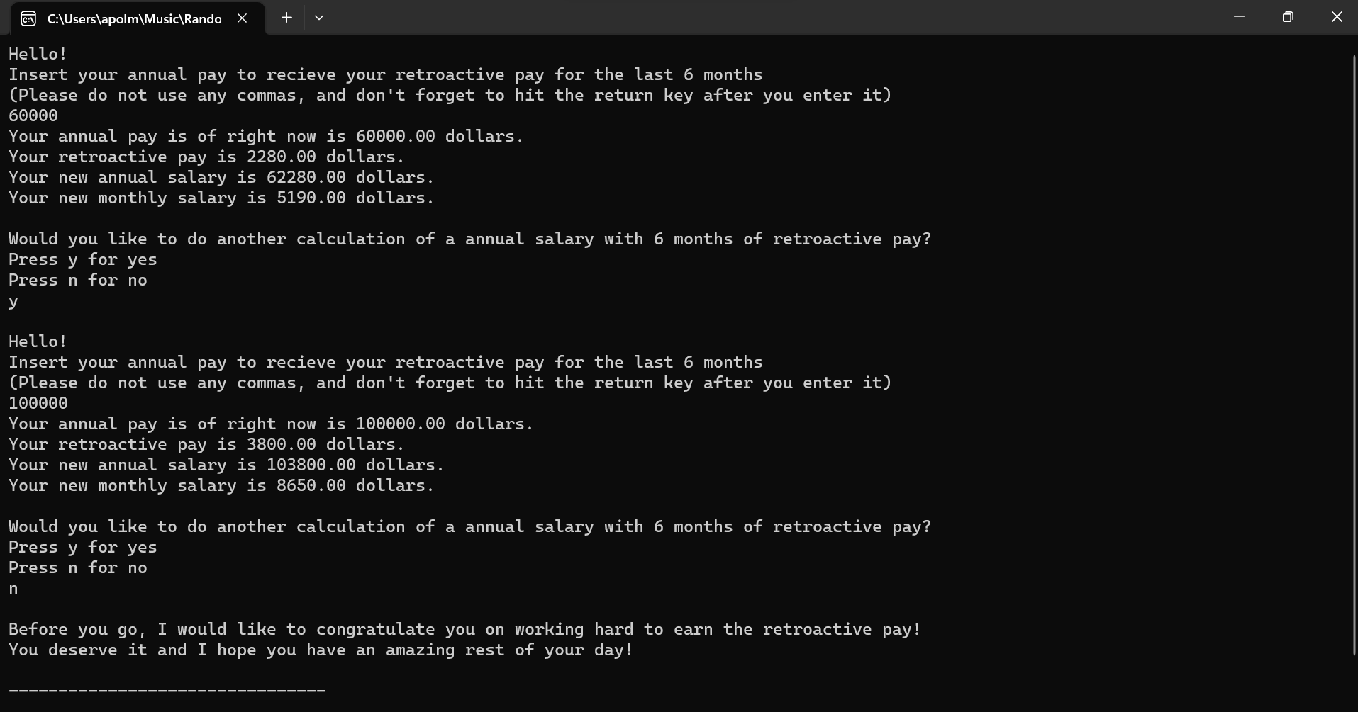

3. Give a number and see if it is a prime number.

#include <iostream>
using namespace std;
int main ()
{
int n;
char ans;

do
{
cout << "Insert a number to see if it is a prime number." << endl;
cin >> n;
cout << "The number you choose was " << n << "." << endl
<< endl;

if (n == 0)
{
cout << n << " is undefined." << endl;
}
else if (n == 1)
{
cout << n << " is technically not a prime number, but truely is a standard." << endl;
}
else if (n == 2)
{
cout << n << " is a prime number." << endl;
}
else if (n == 3)
{
cout << n << " is a prime number." << endl;
}
else if (n == 5)
{
cout << n << " is a prime number." << endl;
}
else if (n%2 > 0)
{
if (n%3 > 0)
{
if (n%5 > 0)
{
cout << n << " is a prime number." << endl;
}
else
{
cout << n << " is not a prime number." << endl;
}
}
else
{
cout << n << " is not a prime number." << endl;
}
}
else
{
cout << n << " is not a prime number." << endl;
}

cout << endl
<< "Would you like to play again?" << endl
<< "Y for Yes, N for No." << endl;
cin >> ans;
cout << endl;

}while ((ans == 'y') || (ans == 'Y'));

cout << "Thank you for playing along! Have a great rest of your day :)" << endl;
return 0;
}
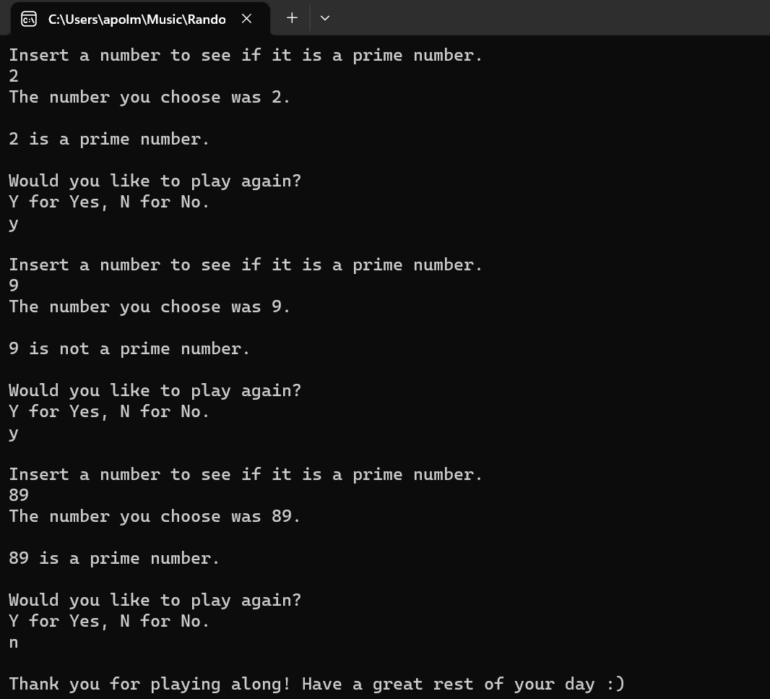

4. Write a C++ program that can print:
*****
****
***
**
*

#include <iostream>
using namespace std;
int main ()
{
int stars;

cout << "Please press the return key after you insert your number." << endl
<< "How long would like the star pattern to be?\n";
cin >> stars;
cout << endl;

for (int levels=1;levels<=stars;levels++)
{
for (int length=stars;length>=levels;length--)
{
cout << "*";
}
cout << endl;
}

cout << endl;
cout << "Wow. Pretty cool, right!\n"
<< "Thank you user for letting me show you my C++ prowess!" << endl;
return 0;
}

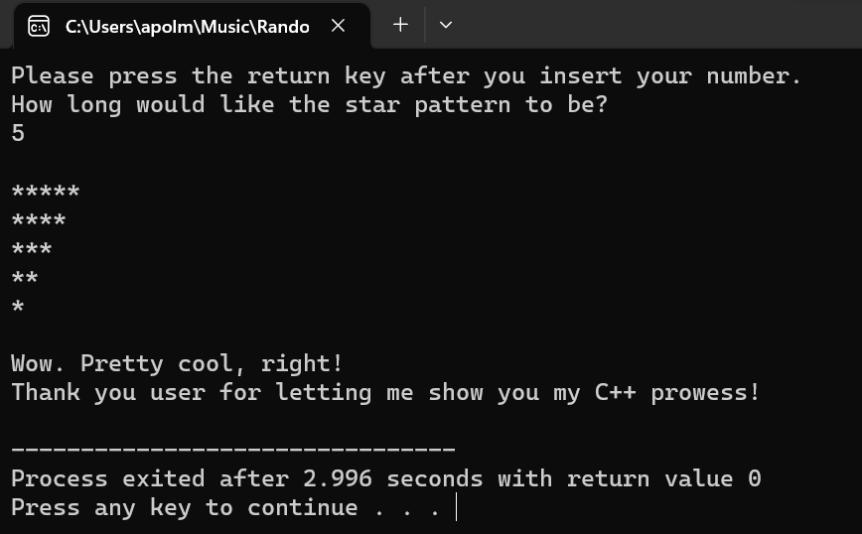

5. Write a program that has an input time in seconds and produce the time in hours, seconds, minutes (output format: hours: minutes : seconds )

#include <iostream>
using namespace std;
int main ()
{
int time, hr_t, r_hr, m_t, r_m, s_t;
const int hr = 3600, min = 60, sec = 1;

cout << "Enter your time in seconds. (No commas please)" << endl;
cin >> time;
cout << endl;

(hr_t = time/hr);
(r_hr = time%hr);
cout << "Your time so far in hours is " << hr_t << "." << endl
<< endl;

(m_t = r_hr/min);
(r_m = r_hr%min);
cout << "Your time remaining time in minutes is " << m_t << "." << endl
<< endl;

(s_t = r_m/sec);
cout << "The last bit of your time in seconds is " << s_t << "." << endl
<< endl;

cout << "In conclusion, the time you entered of " << time << " seconds," << endl;
cout << "can be written as: " << hr_t << " hours, " << m_t << " minutes, and " << s_t << " seconds. \n";
cout << endl;
cout << "Thank you for your time!" << endl;
return 0;
}
